The Trapper
By Charles Daigle

The Trapper
The trapper is generally a person in excellent physical health. He must rise early and eat a good meal since he will have to cover long distances on foot.

Trapping area

The trapper goes mostly along brooks, rivers and lakes. The trap cannot be placed at random; its location must be carefully chosen. If a trapper sees a marten or a fur-bearing animal, he must first feed it and accustom it to the trap. In other words, he tames and feeds the animal in summer, so that by the fall it is ready to be trapped.

The different kinds of traps
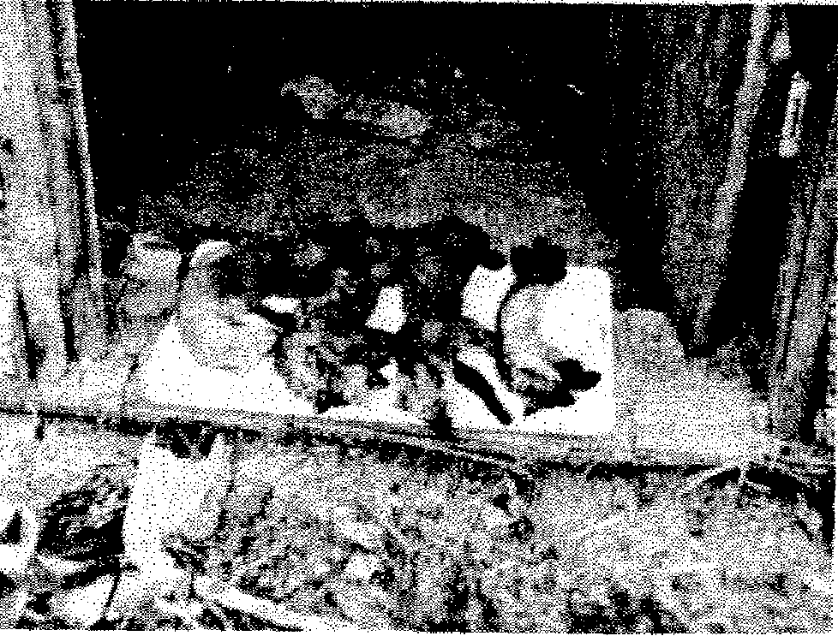
When I hunt, I use #2, #3 and sometimes #4 traps. With a #2 trap I can catch marten, mink, muskrat, skunk, and even fox. A #3 trap is very strong and is adapted for bigger animals like the Canadian marten, the fox, the otter, the lynx, and even the beaver. Finally, a # 4 trap is made specifically for the beaver.
There are also some square snares that we call “corner bear”. They are very sturdy and will kill the prey instantly. The animal that passes in this trap gets its back broken but the pelt is kept intact. At all cost, we must avoid making a hole in the pelt.

The baits
Fur-bearing animals are not hard to please. They eat almost anything that is edible. But certain animals are cunning and will not always eat just anything. They will not even come near certain bait. Thus, martens will eat beef fat, partridge or hare intestines; on the other hand, minks prefer fish. Foxes are fussier; they will eat fish, hare or partridge but prefer beaver meat above all.
A trapper who is interested in many types of furbearing animals will use beef or fish as bait. With these, he can attract marten, mink, and weasel et cetera.

The catches
A good trapper can capture as many as 250 fur-bearing animals a year. That includes all types of animals - marten, fox, mink, beaver, etc...
A trapper, who catches 250 animals or more, must count on at least fifty well-located snares. He has no time to lose. He must get up early, around 7 A.M., and often work past midnight. He stops only to eat. After checking his traps, he must start skinning his catches. Doing the rounds of his traps occupies most of his day since he must rebuild the snares as he goes. To make a trap ready can take as long as half an hour. When he is done readying his traps, he returns to his cottage for the skinning. Two days later, he goes back to his traps, sometimes hoping not to have so many catches.

The skinning
A trapper uses several tools: a sharp knife, a fine stone, a leather thong, a hammer, nails, a mould, a small bench and some strings.
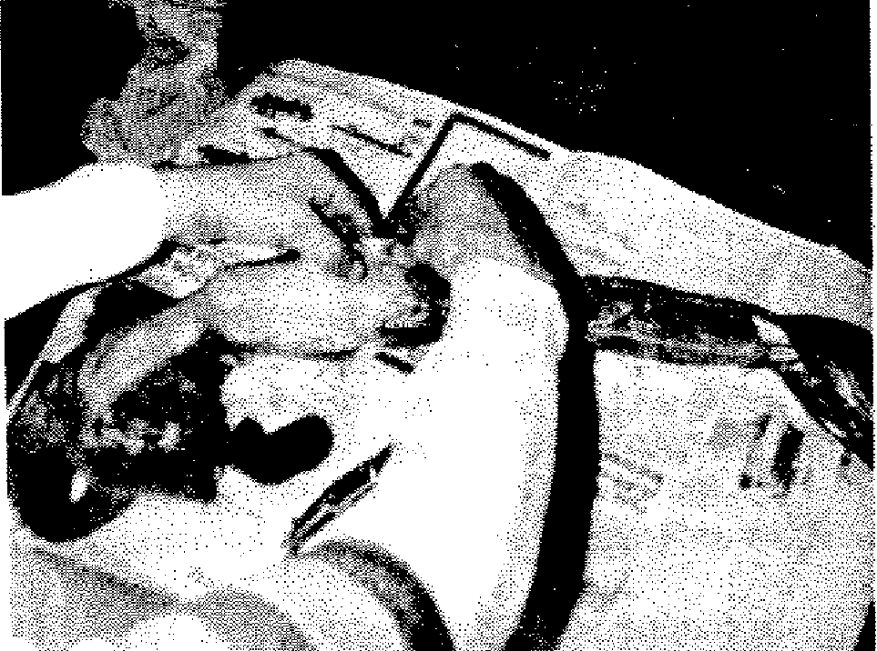
He starts by cutting the back of the hind legs; then he splits the tail and removes the fur from the tail bone. He cuts around the anus, and then pulls the skin towards the front of the animal taking care not to damage the skin with his knife. A short moment of distraction can render the skin unusable and result in a serious loss of time.

The stretching
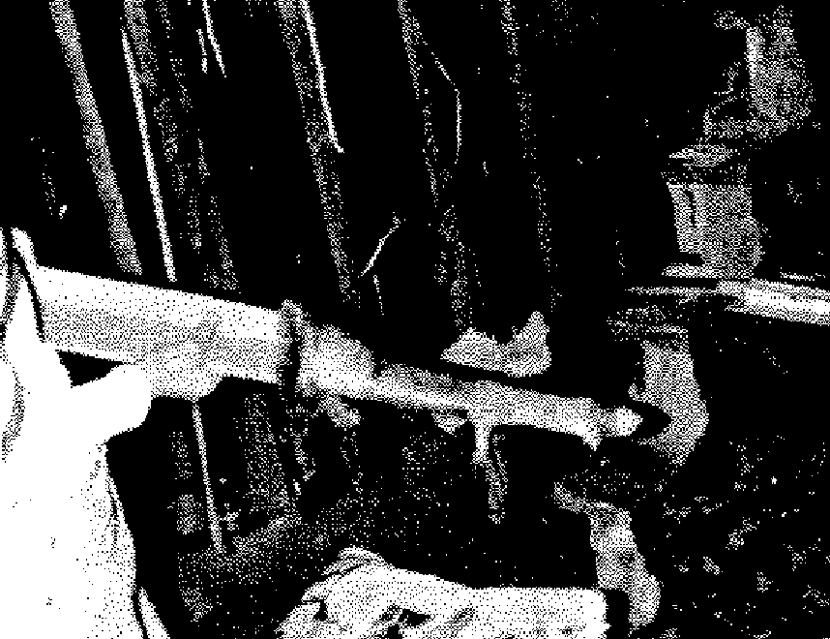
After skinning the animal, he must place the skin on a mould to make sure the skin does not shrink or wrinkle while drying.

Drying
An experienced trapper can skin a marten in 15 minutes. The skinning of the bigger Canadian marten (pekan) can take about half an hour but a mature and fat beaver can take an hour and a half. The time needed for drying varies according to the kind of animal. A marten skin takes one day to dry but the larger Canadian marten (pekan) can take up to four days since its skin is thicker. We must reverse the skin of those two animals. As to the beaver skin, it could take 4 to 5 days to dry but we do not need to reverse it. The pelt must be stored in a dry place for the first day; then, we can place it in a damper storage to make sure the skin does not lose its oily coat. A beaver skin that loses its oil has less value.

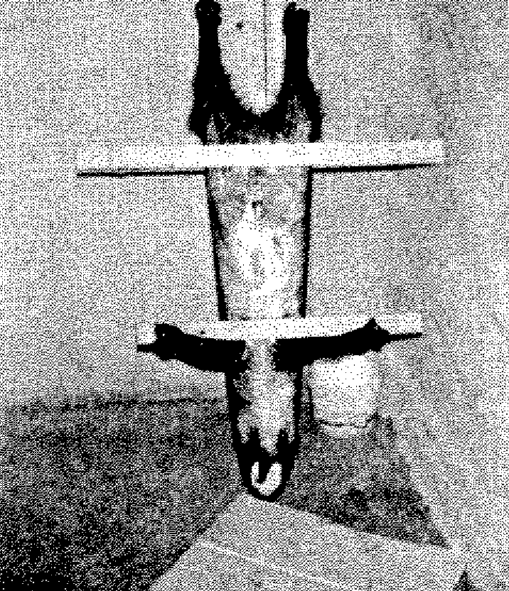

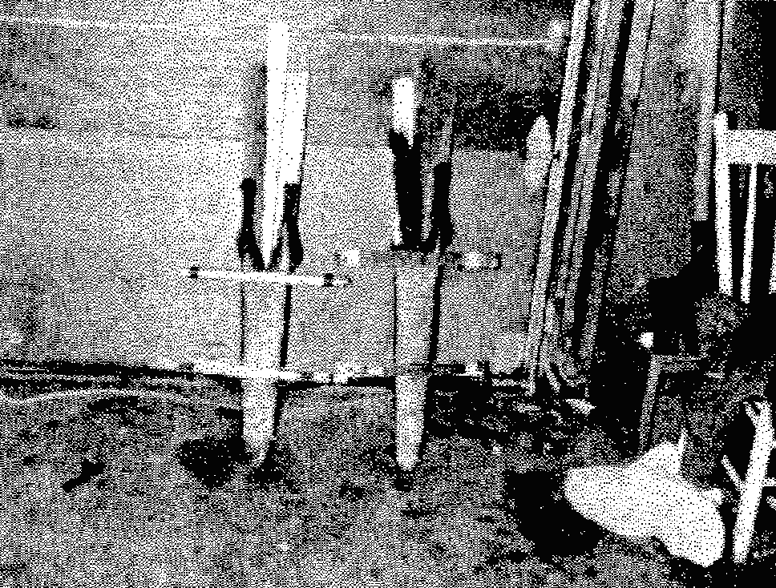
The price of pelts and seasons
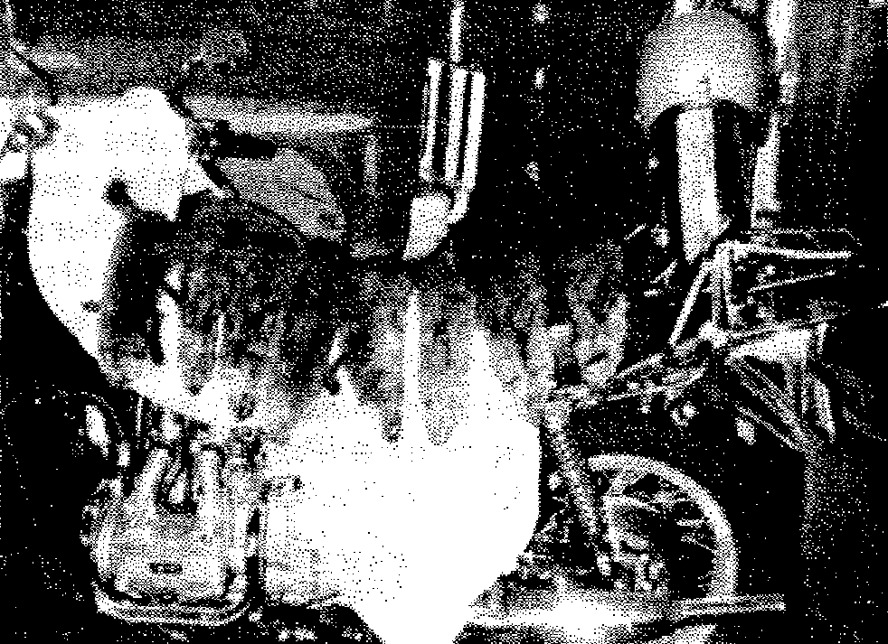
Furs reap a good price. They can sell for up to 300 dollars a skin, depending on the season and the quality of the skinning. A marten in December is fatter and has a dark brown color. Its skin is worth about 15 dollars. At least that is what the Hudson’s Bay Company offers. The Canadian marten is worth more than a fox. A 2-year-old female can be worth about 200 dollars. As for the mountain mink, one can fetch up to 300 dollars. Mr. Ludovic Martin told me this,” As for me, my best year happened 25 years ago. In those days, many people worked for 50 cents an hour. But a trapper that caught one Canadian marten could easily get up to 150 dollars for a single skin. My best year brought me about 5000 dollars. I would start trapping November 1st and stop on January 31st. After that I would catch a couple more animals, but with 5000 dollars in my pocket, I would just lie down to rest and forget about it (trapping)."

